### Practical File

### Of

### Problem Solving using Python Programming

### 23CS001

#### Submitted

#### in partial fulfillment for the award of the degree of

## BACHELEOR OF ENGINEERING

***in***

COMPUTER SCIENCE & ENGINEERING



**CHITKARA UNIVERSITY**

**CHANDIGARH-PATIALA NATIONAL HIGHWAY**

**RAJPURA (PATIALA) PUNJAB-140401 (INDIA)**

##### December, 2023

##### **Submitted To: Submitted By**

##### **Faculty Name: Name: Herish Kumar**

### Designation: Roll no:- 2310990688

### Chitkara University,Punjab Sem, Batch

**INDEX**

|  |  |  |
| --- | --- | --- |
| **Sr.no** | **Practical Name** | **Teacher Sign** |
| 1. | a) Write a [Python Program to Calculate the Area of a Triangle](https://www.programiz.com/python-programming/examples/area-triangle)  b) Write a [Python Program to Swap Two Variables](https://www.programiz.com/python-programming/examples/swap-variables)  c) Write a [Python Program to Convert Celsius to Fahrenheit](https://www.programiz.com/python-programming/examples/celsius-fahrenheit) |  |
| 2. | a.) Write a [Python Program to Check if a Number is Odd or Even](https://www.programiz.com/python-programming/examples/odd-even)  b.) Write a [Python Program to Check if a Number is Positive, Negative or 0](https://www.programiz.com/python-programming/examples/positive-negative-zero)  c.) Write a [Python Program to Check Armstrong Number](https://www.programiz.com/python-programming/examples/armstrong-number) |  |
| 3. | a.) Write a Python program to check if a given number is Fibonacci number?  b.) Write a Python program to print cube sum of first n natural numbers.  c.) Write a Python program to print all odd numbers in a range. |  |
| 4. | a.) Write a Python Program to Print Pascal Triangle  Hint: Enter number of rows: 4  1  1 1  1 2 1  1 3 3 1  b.) WAP to Draw the following Pattern for n number:  1 1 1 1 1  2 2 2 2  3 3 3  4 4  5 |  |
| 5. | Write a program with a function that accepts a string from keyboard and create a new string after converting character of each word capitalized. For instance, if the sentence is “stop and smell the roses” the output should be “Stop And Smell The Roses” |  |
| 6. | a.) Write a program that accepts a list from user. Your program should reverse the content of list and display it. Do not use reverse () method.  b)  Find and display the largest number of a list without using built-in function max (). Your program should ask the user to input values in list from keyboard. |  |
| 7. | Find the sum of each row of matrix of size m x n. For example, for the following matrix output will be like this:    Sum of row 1 = 32  Sum of row 2 = 31  Sum of row 3 = 63 |  |
| 8. | a) Write a program that reads a string from keyboard and display:  * The number of uppercase letters in the string.  * The number of lowercase letters in the string.  * The number of digits in the string.  * The number of white space characters in the string.  b) [Python Program to Find Common Characters in Two Strings](https://www.sanfoundry.com/python-program-check-common-letters-string/).  c) [Python Program to Count the Number of Vowels in a String](https://www.sanfoundry.com/python-program-count-number-vowels-string/). |  |
| 9. | a) Write a Python program to check if a specified element presents in a tuple of  tuples.  Original list:  ((‘Red’ ,’White’ , ‘Blue’),(‘Green’, ’Pink’ , ‘Purple’), (‘Orange’, ‘Yellow’, ‘Lime’))  Check if White present in said tuple of tuples!  True  Check if Olive present in said tuple of tuples!  False  b) Write a Python program to remove an empty tuple(s) from a list of tuples.  Sample data: [(), (), ('',), ('a', 'b'), ('a', 'b', 'c'), ('d')]  Expected output: [('',), ('a', 'b'), ('a', 'b', 'c'), 'd'] |  |
| 10. | a) Write a Program in Python to Find the Differences Between Two Lists Using Sets. |  |
| 11. | a) Write a Python program Remove duplicate values across Dictionary Values.  Input : test_dict = {‘Manjeet’: [1], ‘Akash’: [1, 8, 9]}  Output : {‘Manjeet’: [], ‘Akash’: [8, 9]}  Input : test_dict = {‘Manjeet’: [1, 1, 1], ‘Akash’: [1, 1, 1]}  Output : {‘Manjeet’: [], ‘Akash’: []}  b) Write a Python program to Count the frequencies in a list using dictionary in Python.  Input : [1, 1, 1, 5, 5, 3, 1, 3, 3, 1,4, 4, 4, 2, 2, 2, 2]  Output :  1 : 5  2 : 4  3 : 3  4 : 3  5 : 2  Explanation : Here 1 occurs 5 times, 2 occurs 4 times and so on... |  |
| 12. | a) Write a Python Program to Capitalize First Letter of Each Word in a File.b.) Write a Python Program to Print the Contents of File in Reverse Order. |  |
| 13. | Write-a-program:-*to catch an exception and handle it using try and  except code blocks. |  |
| 14. | Write a Python Program to Append, Delete and Display Elements of a List using Classes. |  |
| 15. | Write a [Python Program to Find the Area and Perimeter of the Circle using Class](https://www.sanfoundry.com/python-program-class-compute-area-perimeter-circle/). |  |

|  |  |  |  |
| --- | --- | --- | --- |
| 16. |  | Create an interactive application using Python's Tkinter library for graphics programming. |  |

**Program 1:**

**A)**

**Title of program: Write a** [**Python Program to Calculate the Area of a Triangle**](https://www.programiz.com/python-programming/examples/area-triangle)**.**

## B)

## Title of program: Write a [Python Program to Swap Two Variables](https://www.programiz.com/python-programming/examples/swap-variables).

## C)

## Title of program: Write a [Python Program to Convert Celsius to Fahrenheit](https://www.programiz.com/python-programming/examples/celsius-fahrenheit).

**Solution:**

**A)**

#### 

## Input:

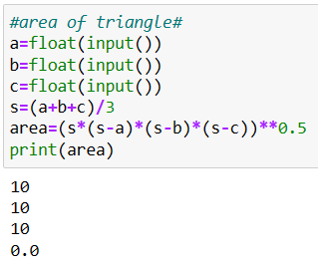

## Output:

# 

**B)**

## Input:

## 

**Output:**

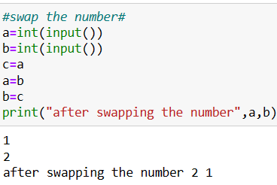

**C)**

## Input:

## 

**Output:**

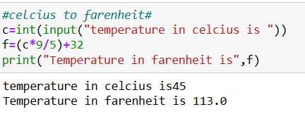

### Program 2:

### A)

### Title of program: Write a [Python Program to Check if a Number is odd or Even](https://www.programiz.com/python-programming/examples/odd-even).

### B)

Title of program: Write a [Python Program to Check if a Number is Positive, Negative or 0](https://www.programiz.com/python-programming/examples/positive-negative-zero).

### C)

### Title of program: Write a [Python Program to Check Armstrong N](https://www.programiz.com/python-programming/examples/armstrong-number)umber.

### Solution:

### A)

## Input:

## 

## Output:

## 

### B)

### Input:

### 

## Output:

### 

### C)

## Input:

## 

## Output:

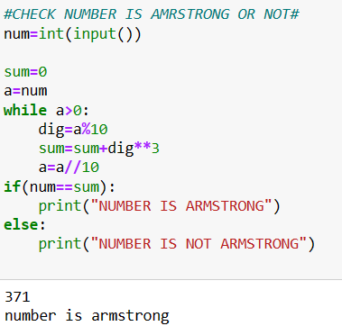

**Program 3:**

**A)**

Write a Python program to check if a given number is Fibonacci number?

**B)**

Write a Python program to print cube sum of first n natural numbers.

### C)

### Write a Python program to print all odd numbers in a range.

### Solution:

**A)**

## Input:

## 

## Output:

## 

**B)**

## Input:

## 

## Output:

### 

**C)**

## Input:

## 

### 

### 

## Output:

## 

### Program 4:

### A)

### Write a Python Program to Print Pascal Triangle.

(Hint:- Enter number of rows: 4

1

1 1

1 2 1

1 3 3 1 )

### B)

Write a Python Program to draw the following pattern for n number:

1 1 1 1 1

2 2 2 2

3 3 3

4 4

### 5

### Solution:

### A)

## Input:

## 

## Output:

## 

### B)

## Input:

## 

## Output:

## 

### Program 5:

### Write a program with a function that accepts a string from keyboard and create a new string after converting character of each word capitalized. For instance, if the sentence is {“stop and smell the roses”} the output should be {“Stop And Smell The Roses”}

### Solution:

## Input:

## Output:

# Program 6:

### Write a program that accepts a list from user. Your program should reverse the content of list and display it. Do not use reverse () method.

### b)  Find and display the largest number of a list without using built-in function max (). Your program should ask the user to input values in list from keyboard

## Solution:

## A)

### Input:

### 

### Output:

### 

## B)

### Input:

### 

## Output:

### 

# Program 7:

Find the sum of each row of matrix of size m x n. For example, for the following matrix output will be like this:

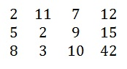

Sum of row 1 = 32

Sum of row 2 = 31

# Sum of row 3 = 63

## Solution:

### Input:

### 

### Output:

### 

# Program 8:

a) Write a program that reads a string from keyboard and display:

* The number of uppercase letters in the string.

* The number of lowercase letters in the string.

* The number of digits in the string.

* The number of white space characters in the string.

b) [Python Program to Find Common Characters in Two Strings](https://www.sanfoundry.com/python-program-check-common-letters-string/).

#### c) [Python Program to Count the Number of Vowels in a String](https://www.sanfoundry.com/python-program-count-number-vowels-string/)

## Solution:

## A)

### Input:

### 

### Output:

### 

## B)

### Input:

### 

### Output:

### 

## C)

### Input:

### 

### Output:

### 